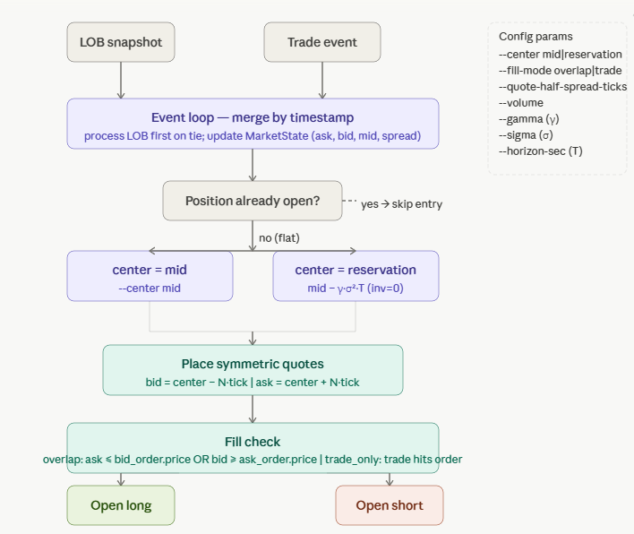

That's the entry side. Now the exit logic — which has three independent conditions checked on every event.
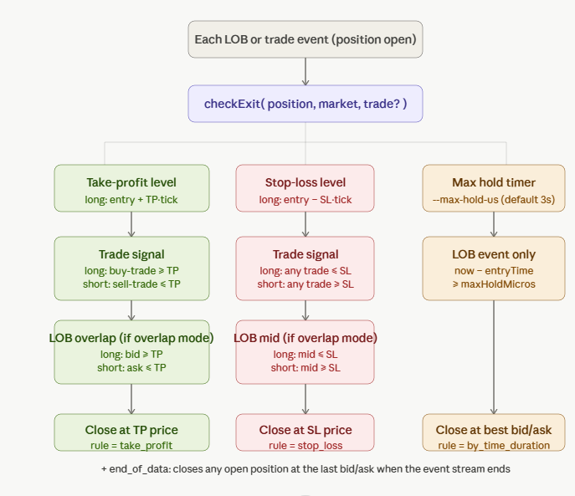

The full picture
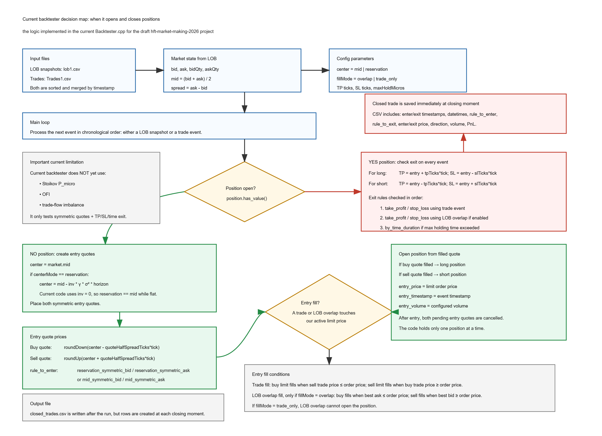

Entry (top diagram): On every event the backtester first checks whether a position is already open. If flat, it computes a quote center — either raw mid or Avellaneda-Stoikov reservation price (mid − γσ²T, though inventory is zero pre-fill so both are equal today) — then places a symmetric bid N ticks below and ask N ticks above. A fill is detected in two ways depending on --fill-mode:
- overlap — on a LOB update, if the best ask has dropped to or below the bid order price (or best bid risen to or above the ask order price), the order is filled immediately at the quoted price.
- trade_only — only an actual tape trade that crosses the order price triggers a fill.
The rule_to_enter column in the output CSV will be either mid_symmetric_bid, mid_symmetric_ask, reservation_symmetric_bid, or reservation_symmetric_ask.

Exit (bottom diagram): On every subsequent event, three independent conditions are evaluated in order:
- Take-profit (green): long exits when a buy-trade reaches TP or LOB bid rises to TP; short exits symmetrically. Exit price = exact TP level.
- Stop-loss (red): long exits when any trade hits SL or LOB mid falls to SL; short exits symmetrically. Exit price = the triggering trade price or best bid/ask.
- Time exit (amber): checked on LOB events only — if now − entryTimestamp ≥ maxHoldMicros, the position is closed immediately at the current best bid (long) or best ask (short).
Whichever fires first wins. The rule_to_exit column records take_profit, stop_loss, by_time_duration, or end_of_data (stream exhausted).

